Task 3: Create a program that asks for a number and then outputs it in Binary, and Hex.

In this program take an input number and convert it to binary and hex number.

**Working Procedure:**

This is C# Console Program. When I run this program at first it show a message that is “Enter the number” that is asking to take a number. After taking a number it convert binary number. After convert it show “Binary number is ‘result’ ”. After showing binary number it converts that insert number to Hex number. After converting this number it show “Hex number is ‘Result’ ”,

**Algorithm:**

In this program take a variable and input a number in this variable. Then it calculate binary using while loop. After calculating Binary It show the binary number. Then it calculates Hex. After calculate hex it show Hex number.

**Exception Handling:**

In this program I use try catch for error handling.

**Code:**

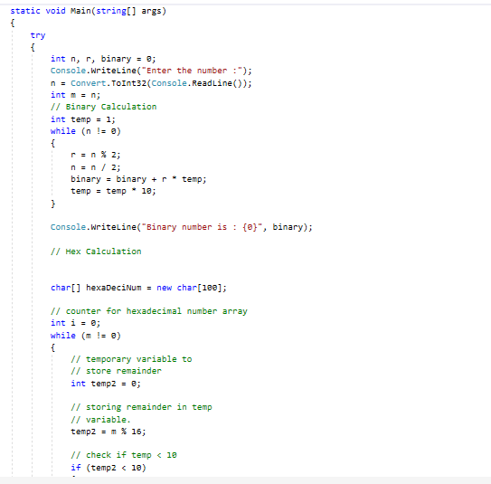

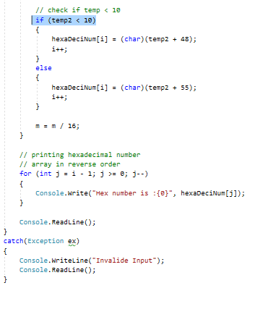

**Output:**

